MACH4METAL

metalworking machinery
Transito 21, 6909 DA Babberich, Netherlands
Tel. + 31 (0)316 – 247123
Fax. + 31 (0)316 - 247956

Bank No : 66.52.13.883
IBAN : NL33 INGB 0665 2138 83
BIC : INGBNL2A
VAT : NL 815393635B01

MAZAK INTEGREX E-800 V/5 II
SUPER MULTI TASKING

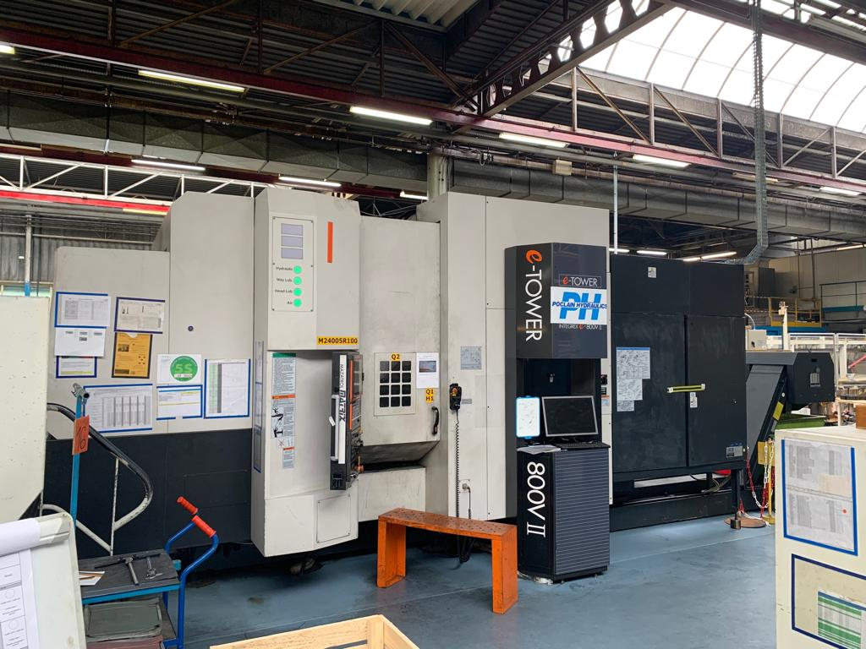
- Make : MAZAK YAMAZAKI
- Type : INTEGREX e-800/v5 II
- YOP : 2007
- Serial : 195183

- X Axis : 1.100
- Y Axis : 800
- Z Axis : 900
- B Axis : - 30 / + 120 Gr
- C Axis : 360.000
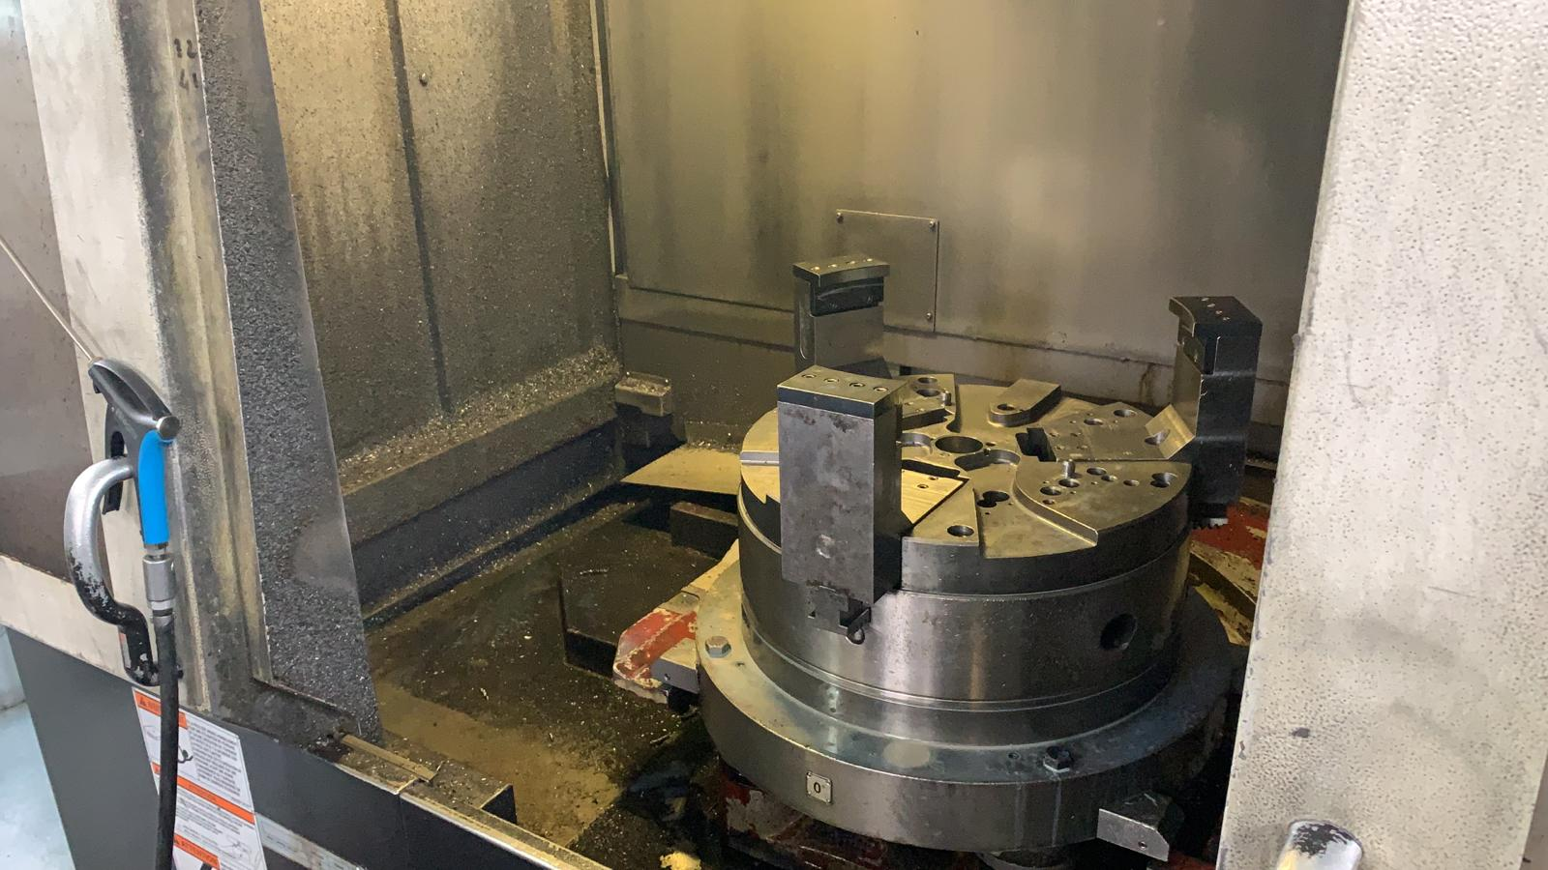
- Maximum size products
- Ø 730 x 1000 height x 880 Kg

- Table size Ø : 610
- Table speed : 1000 Rpm
- Indexing : 360.000

- 5 Axis simultaneous milling
- Speeds : 12.000 Rpm
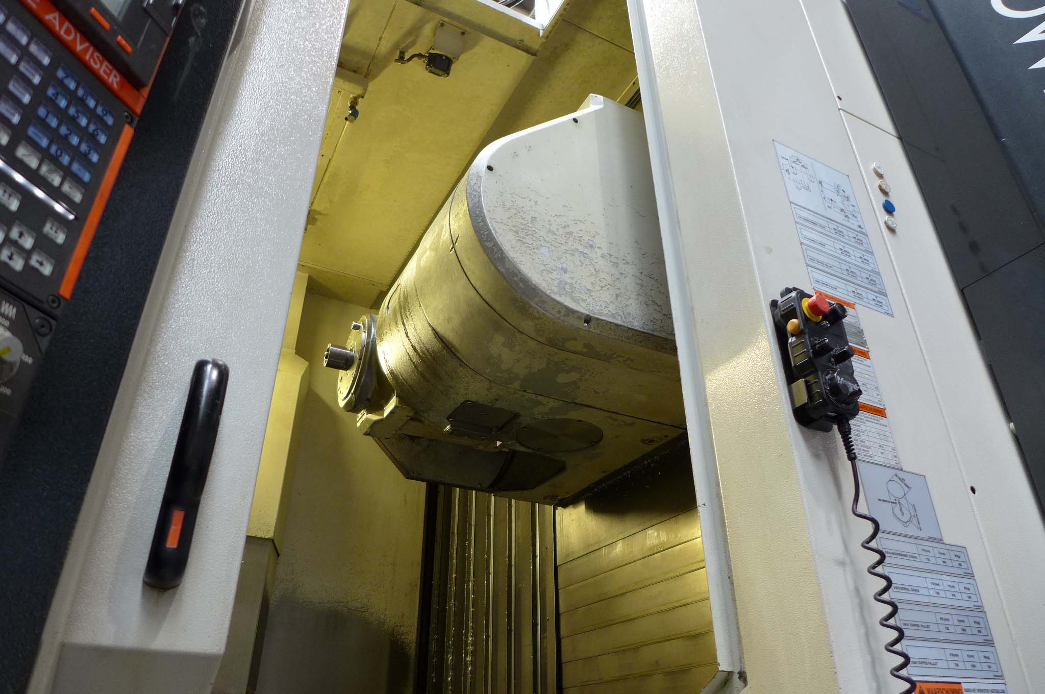
- Spindle taper : Capto C6

- Chain ATC 120 positions CAPTO C6
- Double chip conveyor
- High pressure coolant system

- CNC Control E Tower Mazatrol MATRIX
Equipped with software for:
spiral interpolation, cutter compensation,
pattern rotation, scaling, treading, polar input

- Dimensions 7.700 x 3680 x 3450 H
- Weight 22.500 Kg
- Table 30 kW / Milling 20 kW

Please Note: The above information has been obtained to the best of our ability and belief from, and from the manufacturers where possible. It is given in good faith, but its accuracy can not be guaranteed. Accordingly, it will not form a representation or constitute contractual terms. We advise you to check any vital details!

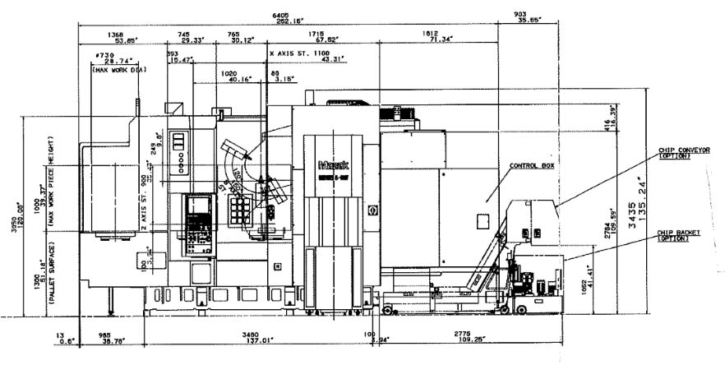

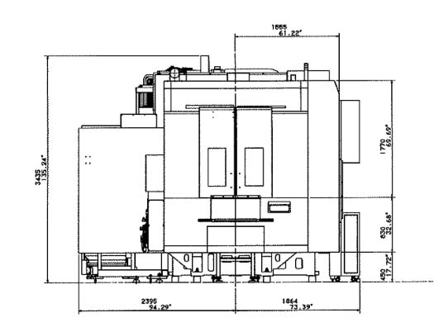

\

Please Note: The above information has been obtained to the best of our ability and belief from, and from the manufacturers where possible. It is given in good faith, but its accuracy can not be guaranteed. Accordingly, it will not form a representation or constitute contractual terms. We advise you to check any vital detail

